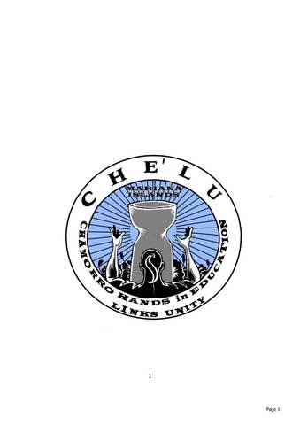
2015 Chamorro Cultural Festival
Vendor Rules

Welcome Vendors!
Thank you for participating in the Chamorro Cultural Fest

Registration and Payment Deadlines
- Food vendors: 5:00 PM, Friday, February 27, 2015
- Retail and Information vendors: 5:00 pm Saturday, March 7. 2015
- Mandatory vendor meeting in mid-March. Place and time to be announced.

All booth payments must be made at the time of registration.
Online payment is available at www.CheluSD.org.

Event Information
- Date: Saturday March 28, 2015
- Time: 10 am – 6 pm
- Location: 333 South Twin Oaks Valley Road, San Marcos, CA 92078

Booth Space
Per vendor registration, vendors will be assigned space for their own 10 x 10 pop up tent, tables and chairs. Table and chair rental is available at an additional cost. As a courtesy to other vendors, please do not set up anything outside of your marked area.

Booth Fees
- Resource/Information space: $100 (with no monetary transactions)
- Retail space: $250
- Food space: $300

A late fee of $25 may be imposed for registrations received after March 7, 2015.
No refunds after March 7, 2015

Set-up: Can be done March 27, 2015 from 5pm to 8pm the evening before the event. On Saturday, March 28, set up begins at 6am. Set up must be completed by 9am. You must make sure your booth is attended at all times. Although security is present, CHE’LU will not be responsible for any lost or stolen items.

Breakdown: Vendor booths must remain open until the close of the event at 6pm. After closing, vendors must remove all trash, displays and merchandise from the space. Breakdown must be completed by 8pm on Saturday March 28, 2015. Vehicles will only be allowed in the vendor area after pedestrian traffic has diminished sufficiently, which will be determined by security.

Clean up: During the event, vendors are responsible for taking care of their own trash and placing it in the event’s large trash container. Do not place trash in unapproved receptacles. Vendors are responsible for cleaning up their booth areas during and after the event. Please do not begin breakdown of your booth prior to 6pm. Final clean up inspection begins promptly at 8pm.

Suitable merchandise and activities: CHE’LU reserves the right to select vendors, organizations and activities that are most suitable for the Chamorro Cultural Festival. Any vendor selling or displaying inappropriate drug(s), paraphernalia, alcohol, controlled substances or other merchandise or displays unsuitability for a family event, will be asked to vacate the event.

Licenses and Permits:
All vendors are responsible for obtaining the required licenses and permits. Merchandise vendors are required to obtain a resale number for the event. Food vendors must obtain the appropriate health permits. Food vendors are responsible for having the prescribed fire extinguisher in their booth.

Booth Décor: CHE’LU reserves the right to reject any vendor whose merchandise, décor or displays are deemed inappropriate for this event.

Space Assignments: 10’ x 10’ spaces will be assigned according to a combination of the festival layout, space needs, seniority and a combination of other considerations. Space assignments are available on Friday, March 27, 2015.

Other: All vendors will be expected to handle their own cash or other monetary transactions.

Mandatory vendor meeting:
You will be notified to attend the mandatory vendor meeting in late March to receive your vendor packet to include:
- Site map
- Booth location
- One parking pass
- Special instructions for Food vendors

For additional information please contact June Hawkins at (619) 655-2782 or email jun.hawkins55@yahoo.com

Please use the 2015 Vendor Registration Online Payment option at www.CheluSD.org or mail registration form and payment to:

CHE’LU
P.O. BOX 742126
San Diego, CA 92174

